
Newsletter
No. 2
December 2021
ERASMUS+ Programme – Key Action 2: Strategic partnership
IENE 10 “PREPARING HEALTH AND SOCIAL CARE WORKERS TO WORK WITH SOCIALLY ASSISTIVE ARTIFICIALLY INTELLIGENT ROBOTS IN HEALTH AND SOCIAL CARE ENVIRONMENTS”
Agreement number: 2020-1-UK01-KA202-078802

Introduction |  | The IENE 10 project aims to produce a European Transcultural Robotic Nursing (TRN)  curriculum and learning materials which will  be suitable for health and social care workers and  educators, not only within the partnership of this project but also internationally.  Τhe TRN curriculum is designed to promote culturally competent and compassionate transcultural care with the use of artificial intelligence and social robotics. The TRN curriculum aspires to adapt to contemporary challenges and act as an enabler in the caring of those in need. The TNR curriculum also aims to increase knowledge on TRN and provide a comprehensive knowledge map about TRN.  The TRN curriculum model will be used as a guide for the development of the training modules, materials, learning tools and finally the creation and implementation of a Massive Open Online Course (MOOC). A report on the development of the TRN modules will be available in the languages of all partners.  The TRN curriculum model was developed based on the:  - International, European and national literature review  - Thematic areas derived from other literature reviews  - The revised Papadopoulos, Tilki and Taylor model  - Papadopoulos model for “Culturally Competent Compassion” | THE LOGO OF THE PROJECT  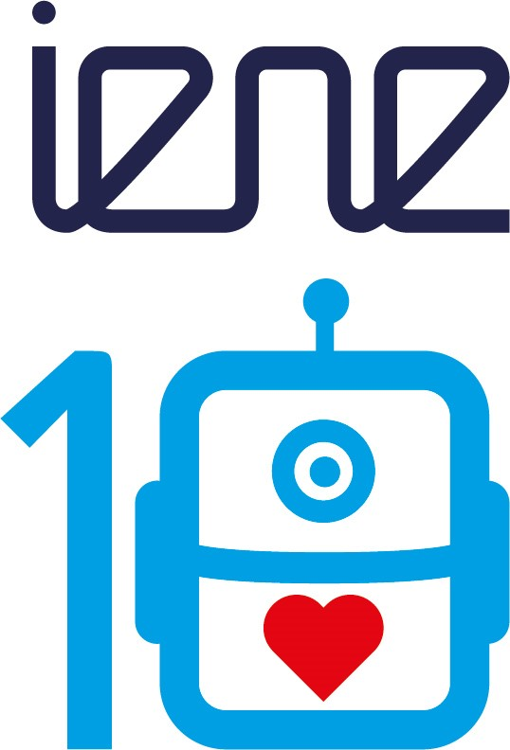
Output 2  Development of the Transcultural Robotics Nursing Modules |  | Output 2 aims for the development of the TRN modules based on the values, and philosophy of the PTT/IENE curriculum framework. There will be 4 TRN modules based on the main model constructs. Each module will have learning aims and objectives to assure achievement of all the topics included in the maps of sub-constructs, as shown in the diagram.  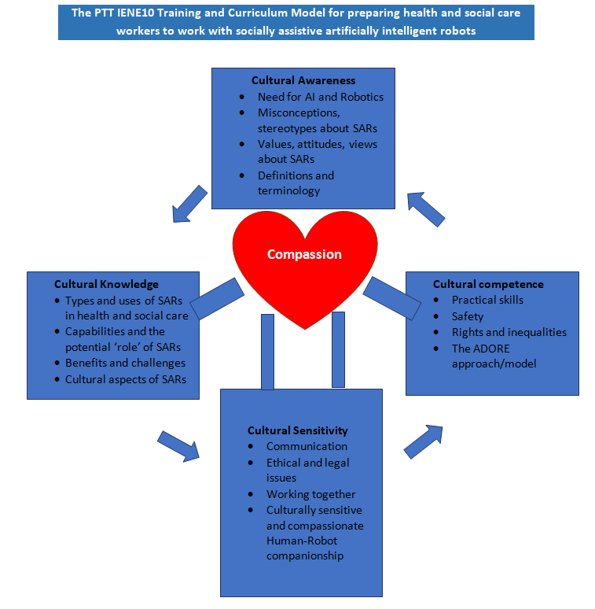
Output 3  Developing Learning Tools |  | Sixteen learning units (tools) were created, for each of the four key sub-constructs in each of the four modules, using a template with links to text, glossaries, articles, worksheets, audios, youtube videos, games and quizzes. The completed templates for each learning unit will be uploaded on the project’s website to be freely downloaded by interested parties. All learning units will be translated into partner’s language as well.
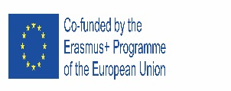  3rd Transnational meeting (online) |  | The main topic of the meeting was mainly the preparation of the learning units and the allocation of the work to the partners. Furthermore, the coordinator informed the partners for the three different platforms being considered for the MOOC. The proposed logo of the project was presented and the participants made their comments.            
^{4th} Transnational meeting in Cyprus  (face to face) |  | The main objectives of the meeting were to:  - Familiarise and understand all aspects of the project  - Discuss the progress with learning units for the MOOC training  - Present the MOOC platform and understand how it will work  - Present and discuss the proposal for the IENE website refresh  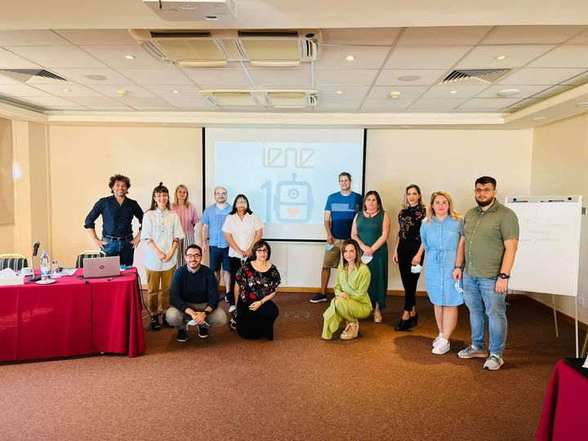
Next meeting |  | The next meeting will be in March 2022 in Genova, Italy
This project has been funded with support from the European Commission. This publication reflects the views only of the author, and the Commission cannot be held responsible for any use which may be made of the information contained therein. |  |         

